GUIDELINES
FOR CTE
INTERNSHIPS

www.sandiegounified.org/ccte

GUIDELINES FOR CTE INTERNSHIPS

The purpose of this document is twofold:

- To assist teachers with the necessary information to properly enroll students in internships.

- To assist teachers in the implementation and compliance with Title 5 of the California Code of Regulations (CCR) for the two Internship Programs (CC-Community Classroom and CVE-Cooperative Vocational Education).

Community Classroom (CC) and Cooperative Vocational Education (CVE) have proven to be extremely effective methods of instruction and are unique in providing a combination of related classroom instruction and paid or unpaid internship in a business/industry setting. The importance of work-based learning as a highly effective means of developing solid job skills has long been recognized.

CC and CVE internship methodologies take place at business/industry sites where occupational training programs are conducted. Their purpose is to expand occupational training opportunities by utilizing existing sites and facilities other than those of the traditional classroom. Each student’s vocational preparation is therefore jointly planned and supervised by the teacher and the business. This shared responsibility is facilitated through a written Individualized Training Plan (ITP). The ITP ensures that each student intern experiences a progression of learning activities at the training sites.

Objectives for Internships for Student Interns

- To reinforce academic skills.

- To provide basic background instruction to help prepare for business/industry occupations and related professions.

- To facilitate the transition between school and employment.

- To provide training sites to practice skills and foster positive attitudes learned in the classroom.

- To provide practical experiences that will help make their classroom instruction more meaningful.

- To provide an opportunity, through the use of local business, to acquire skills and knowledge that are best developed through work-based learning.

- To provide opportunities to make social adjustments and to develop the ability to work cooperatively with co-workers and supervisors.

- To emphasize the importance of being able to follow directions, pay attention to details, and accept supervision.

- To foster an understanding of the benefits and responsibilities of gainful employment.

- To provide the ability to keep up with the changing world of work with emphasis on problem-solving, thinking, and decision-making.

- To provide instruction in business skills, principles, and concepts that will lead to success work-based learning.

- To provide counseling to continue training beyond high school.

- To demonstrate that constant educational growth is necessary for successful employment and good citizenship.

- To graduate well-trained, experienced workers.

Community Classroom (CC)

Requirements:

- Compensation: Student is not paid.
- Work Permits: None are required.
- Workers’ Compensation Insurance: Covered by San Diego Unified School District.
- Minimum/Maximum hours per week: standards vary from instructor and course catalog.
- Placement: A CC intern must be placed in an internship directly related to his/her CTE course.
- Related Instruction: Student must attend a minimum of 108 classroom hours for a year course and 54 classroom hours for a semester course or a 4x4 term. Teacher must provide a minimum average of three instructional periods per week of at least 50 minutes each. A minimum of one instructional period shall still be conducted per week after students are placed.
- Supervision Visitations: teacher must visit intern once every three weeks at the training site.
- Attendance Reporting: maximum worksite training not more than 5 days per week.
- Maximum Student/Instructor Ratio: thirty (30) students per class; 75 total per instructor.
- Forms Required to be completed (see attached following documents): :
  - CC Internship Training Agreement
  - Intern Participation Agreement/Emergency Information Form
  - Individualized Training Plan
  - Record of Supervision Visits
  - Worksite Experience Evaluation
  - Time Sheets

Cooperative Vocational Education (CVE)

Requirements:

- Compensation: Student is paid.
- Work Permits: They are required (if under 18 years of age).
- Workers’ Compensation Insurance: covered by employer.
- Minimum/Maximum hours per week: over 18 years of age no restrictions/under 18 years of age – see work permit form.
- Placement: A CVE intern must be employed in a job directly related to the CTE course.
- Related Instruction: Student must attend a minimum of 108 classroom hours for a year course and 54 classroom hours for a semester course or a 4x4 term. Teachers must provide a minimum average of three instructional periods per week of at least 50 minutes each. A minimum of one instructional period shall still be conducted per week after students are placed.
- Supervision Visitations: teacher must visit intern once every four weeks at the training site.
- Attendance Reporting: maximum worksite training, not more than 5 days per week. Minimum of eight hours up to a maximum of 15 hours of attendance per calendar week. Intern can work more than 15 hours per week but those hours won’t count for ADA.
- Maximum Student Instructor Ratio: thirty (30) students per class, 75 total per instructor.
- Forms Required to be completed(see attached following documents):
  - CVE Internship Training Agreement
  - Intern Participation Agreement/Emergency Information Form
  - Individualized Training Plan (
  - Record of Supervision Visits
  - Worksite Experience Evaluation
  - Time Sheets
  - Work Permit (if under 18 years of age)

Community Classroom (CC) Internship Training Agreement

The purpose of the Community Classroom Internship program is to assist _________________________________________________ (“student”), a San Diego Unified School District (“District”) student enrolled in _______________________________________________________ (“course”), to develop the occupational competencies listed on his/her training plan through a combination of related classroom instruction and unpaid work-based learning experiences. The District and _____________________________________________________________________ (“training site”) located at _________________________________________________________________ mutually agree to the following responsibilities:

The training site management shall:
- Have a clear understanding of program objectives.
- Provide the student with unpaid internship training experiences in an environment that will not endanger the health, safety, welfare, or morals of the student.
- Provide adequate equipment, materials, and other resources to expand the competencies developed in the related classroom instruction portion of the program.
- Assist in developing student training plans, as evidenced by completion of the Individualized Training Plan. A copy of the training plan shall be maintained at the training site (5 CCR §10087).
- Consult with the community classroom teacher regarding each student’s progress.
- Maintain accurate training records of student’s training hours at the training site.
- Agree to defend, indemnify, protect, and hold harmless the school district, its officers, agents, and employees against any and all losses, injuries, claims, actions, judgments, including attorney fees and costs, and liens which arise from or are connected with the acts or omissions of the training site management, its officers, agents, and employees.

The School District shall:
- Provide concurrent formal vocational related classroom instruction for community classroom students that is: (a) scheduled an average of three 50 minute minimum instructional periods per week for the length of the program and a minimum of one 50-minute instructional period per week, (b) based on the skills, knowledge, attitudes, and related performance levels necessary in the occupation for which training is conducted (5 CCR § 10085(a)).
- Prepare individualized training plans (5 CCR §10083(c)).
- Provide the teacher time for supervision/coordination equivalent to one hour per week for every week for every five community classroom students enrolled. When less than five students are enrolled, a minimum of one hour per week of supervision/coordination shall be provided (5 CCR § 10088(b)). Only the community classroom teacher who provides related classroom instruction shall provide supervision/coordination for the unpaid work-based learning of students (5 CCR § 10088(c)). The maximum number of students per vocational education course section utilizing the community classroom and/or cooperative vocational education methodology shall not exceed 30 at any time (5 CCR § 10089(a)). The maximum number of students assigned to a vocational education teacher, utilizing the community classroom and/or cooperative vocational education methodology, including both related classroom instruction and supervision/coordination, shall not exceed 75 at any time (5 CCR § 10089(b)). The teacher shall make at least one visit every 3 weeks to consult with the training site management, observe students at the training site, provide instruction, and ensure that student acquisition of competencies identified in the individualized training plan is occurring (5 CCR § 10088(a)).
- Locate and select training sites to provide student learning experiences commensurate with their skills.
- Monitor student’s progress by completing the individualized training plan and provide ongoing and final evaluation of the student’s achievement of instruction objectives 5 CCR § 10083(e) and (f)).
- Develop and keep file records, including: training agreements, training plans, records of internship supervision, visitations and observations, and records of students assigned at on-the-job training sites with students’ training hours.
- Agree to defend, indemnify, protect, and hold harmless the training site management, its officers, agents, and employees against any and all losses, injuries claims, judgments, including attorney fees and costs, and liens which arise from or are connected with acts or omissions of the District, its officers, agents, and employees.

All training experiences shall be under the immediate supervision and control of a teacher who is an employee of the District and holds a valid California teaching credential. When the teacher determines that the student has achieved competency, the student will be assigned to training in other competency areas.

The unpaid work-based learning element of the program shall not: (a) provide the management of the community classroom site with an immediate benefit, (b) allow a student to replace an employee of the community classroom site or cause an employee’s hours to be reduced, nor preclude the employee’s hours to be reduced, nor shall the student’s training activities preclude the hiring of additional employees, and (c) include productive work of any kind as defined by State and Federal Labor Regulations (Div.2, Part 4 commencing with Section 201, California Labor Code; Fair Labor Stds. Act, 29 U.S. Code, Sections 201 et seq. (5 CCR § 10090(a)).

Unpaid work-based learning experience shall only expand competencies developed in the classroom instruction portion of the vocational course/program utilizing the community classroom methodology (5 CCR § 10090(b)).

The San Diego Unified School District shall carry Public Liability Insurance and Workers’ Compensation Insurance covering students enrolled in a Community Classroom course and the teacher of a Community Classroom course.

Neither the District nor the training site management shall discriminate against any student or employee on the basis of race, color, national origin, gender, sexual preference, marital status, parental status, or disability in employment practices or in providing work-based learning experiences.

All Community Classroom Internship Training Agreements shall be in effect until terminated or amended by mutual consent of the parties and/or may be terminated upon notice in writing by either party.

_______________________________________________________________
CTE Director’s Signature (or designee) Telephone Number Date

Training Site Management’s Name (Please Print) Telephone Number Date

Training Site Management’s Signature
cooperative vocational education (Cve) Internship Training Agreement

The purpose of the Cooperative Vocational Education Internship program is to assist _________________________________________________ (“student”), a San Diego Unified student enrolled in _______________________________________________________ (“course”), to acquire the occupational competencies listed on their individualized training plan through a combination of related classroom instruction and paid on-the-job training experiences. The San Diego Unified School District (“District”) and _________________________________________________________ (“training site”) located at ___________________________________________________________ mutually agree to the following responsibilities:

The training site management shall:
1. Have clear understanding of the program objectives.
2. Provide adequately supervised paid on-the-job training experiences which (a) are regularly scheduled for a minimum of 8 hours per week, (b) are in an occupation for which the program is approved and for which related instruction is provided, (c) will not endanger the health, safety, welfare, or morals of the student, (d) have adequate equipment, materials and other resources that provide an appropriate learning opportunity, and (e) are in compliance with Federal and State labor laws.
3. Assist in developing training plans, as evidenced by completion of the Individualized Training Plan.
4. Consult with the cooperative vocational education teacher regarding the student’s progress.
5. Maintain training records (including a copy of the training plan) and accurate records of the students’ training hours at the training site.
6. Provide workers’ compensation and other insurance for students employed through the cooperative vocational education program in accordance with existing law.
7. Compensate cooperative vocational education students at least at the minimum wage as stipulated by current California State Industrial Welfare Commission Orders. (A work permit is required for all employees under 18 years of age.)
8. Agree to defend, indemnify, protect, and hold harmless the school district, its officers, agents, and employees against any and all losses, injuries, claims, actions, judgments, including attorney fees and costs, and liens which arise from or are connected with the training site employer, its officers, agents, and employees.
The School District shall:
- Provide concurrent, formal related classroom instruction for cooperative vocational education students that is: (a) scheduled an average of three instructional periods per week for the length of the program with a minimum of one instructional period scheduled per week, and (b) organized to ensure that each student will have sufficient hours of directly related classroom instruction and paid on-the-job training experiences necessary for employment and advancement in the occupation for which training is conducted. (5 CCR §10106a)
- Prepare Individualized Training Plan after locating and selecting training sites.
- Release the cooperative vocational education teacher an average of one hour per week for every five students for supervision. A minimum of one hour per week shall be provided. (Only the teacher of the related classroom portion will supervise the student’s on-the-job training experiences.) (5 CCR §10104g)
- Make supervision visits to training sites every four weeks to observe and ensure compliance with the Individualized Training Plan. (No less than every second visit shall include an observation of the student engaged in on-the-job training experiences.)
- Select and approve students who qualify for enrollment in the program.
- Limit the number of students enrolled in a cooperative vocational education section to 30 students with a maximum of 75 students per full-time cooperative vocational education teacher. (5 CCR §10089a and b)
- Monitor student’s progress, facilitate individualized training plan, and provide ongoing and final student evaluation. (5 CCR §10104)
- Assist students with career planning and identifying employment and educational objectives.
- Develop and keep on records including: evidence of work permits issued, training agreements, training plans, on-the-job supervision observations, and internship site locations with student’s training hours. (5 CCR §10105)
- Agree to defend, indemnify, protect, and hold harmless the training site management, its officers, agents, and employees against any and all losses, injuries, claims, actions, judgments, attorney fees and costs, and liens which arise from or are connected with sole negligence of the school district, its officers, agents, and employees.

Component Parts of this Training Agreement
This training agreement consists of the following documents, all of which, when executed by the appropriate parties, are component parts of the training agreement as is herein set out in full or attached hereto:
- Training Site Plan
- Individualized Training Plan
- Intern Participation Agreement

Neither the School District nor the training site management shall discriminate against any student or employee on the basis of race, color, national origin, gender, sexual preference, marital status, parental status, or disability in employment practices or internship experiences.

All Cooperative Vocational Education Training Agreements are contingent upon the student attending the related classroom portion of the program and shall be in effect until terminated or amended by mutual written consent of the parties.

_______________________________________________________________
CTE Director’s Signature (or designee) Telephone Number Date

Training Site Management’s Name (Please Print) Telephone Number Date

Training Site Management’s Signature
INTERN PARTICIPATION AGREEMENT

The objective of the CTE Internship Program is to contribute to your vocational training by providing opportunities for you to participate in an actual job setting related to your career choice. Because students will be actively involved in the business community and actually training in a business environment, participants must comply with the standards and policies set by the participating employers:

Participation Requirements
- You must complete appropriate internship preparation units, as designated by your instructor, prior to beginning an internship.
- Good grooming is essential in the classroom and at a worksite.
- Absences must be cleared by your school attendance coordinator. Excessive absences will result in dismissal from this training program.

Training Site Standards
- Follow company dress code policy.
- As a member of a school organization, you are not allowed to smoke.
- Tardies and absences are not consistent with a professional attitude.
- You must train for the full time assigned, even if you arrive late.
- Schedule appointments and school activities outside of internship and class time.
- Call the training sites as well as the classroom prior to being absent.
- Return to the classroom as scheduled for related instruction. Missing more than three related classes may result in failing the class and losing your unpaid or paid internship.
- Notify your instructor if you are offered a paid position so arrangements can be made (e.g., work permit).

Positive public relations are required of all interns. Clear communications and understanding will help the year run smoothly. Enjoy, learn, and have a good year!

Emergency Information

Who to contact in case of emergency ____________________________ ____________________ Phone _______________
^{Name} ^{Relationship}
Permission to call: If my child needs emergency medical attention and I cannot be reached, I give CCTE and the attending site supervisor authority to call:

Our family doctor _____________________________________ Phone ___________________ [ ] Yes [ ] No and/or

A CCTE designated emergency clinic/hospital [ ] Yes [ ] No

Please list any special medical instruction (e.g., allergies, vision, seizures, limited physical activity, or other pertinent information).___________________________________________________________________________________
______________________________________________________________________________________________

By signing below, the student (or parent/guardian if student is under 18 years of age) certifies that the student meets all of the following qualifications:
- Is at least 16 years of age, except a student with exceptional needs (for CVE only);
- Is a full time student as defined in Title 5 California Code of Regulations section 10103(b);
- Has parent or guardian approval, if under 18 years of age;
- Is currently enrolled in, and attending at least once per week, the related classroom portion of the program.

I (we) have read, discussed, understand, and agree with the expectations set by the instructor.

Student Signature Date

Parent/Guardian Signature Date

INDIVIDUALIZED TRAINING PLAN (ITP)

❑ Community Classroom (CC)  Cooperative Vocational Education (CVE)

Intern Name Course Title

Intern Home Phone School Instructor

Intern Emergency Phone Instructor Phone

Internship Site Information

Site Name

Site Address

Site Supervisor Name Site Supervisor Phone

Knowledge, Skills, and Abilities  to be developed through internship experience | Expected Duration of  Training | Location of Training  Please check () |  | Attainment Verification
 |  | Classroom | Worksite | Date | Initial

Internship Site Supervisor Signature Date Instructor Signature Date

Intern Signature Date

WORKSITE EXPERIENCE EVALUATION
Student Name
Internship Site
Course

Exceeds Meets Needs Does Not
Expectations Expectations Improvement Apply

1. Works both independently and collaboratively.

2. Attends internship on a regular basis and telephones prior to
absence due to illness or emergency.

3. Comes to work on time.

4. Dresses and is groomed appropriately for the job.

5. Communicates with customers, employees, business contacts
and management.

6. Performs reliably and responsibly.

7. Serves customers, and works well with diverse populations.

8. Performs the essential tasks related to this occupational area.

9. Uses math accurately as required.

10. Practices good safety procedures.

11. Solves problems, thinks critically and makes good decisions.

12. Plans work and takes initiative.

13. Demonstrates ability to manage resources well.

14. Demonstrates leadership and willingness to help and train others.

15. Acquires, evaluates and interprets data appropriately.

16. Works well as a team member within the organization.

17. Selects equipment, applies technology to specific tasks, and
maintains/troubleshoots equipment.

18. Demonstrates poise and confidence.

19. Demonstrates a positive attitude.

20. Produces quality work consistent with assigned objectives.

Comments:

Evaluator’s Signature ____________________________________________________ Date _________________________
INTERNSHIP STUDENT TIME SHEET

Intern Name Course Title
Internship Site Name

DAY | DATE (MM/DD/YY) | TIME IN | TIME OUT | HOURS/DAY
Monday
Tuesday
Wednesday
Thursday
Friday
Saturday
Sunday
Monday
Tuesday
Wednesday
Thursday
Friday
Saturday
Sunday
Monday
Tuesday
Wednesday
Thursday
Friday
Saturday
Sunday
Monday
Tuesday
Wednesday
Thursday
Friday
Saturday
Sunday
Monday
Tuesday
Wednesday
Thursday
Friday
Saturday
Sunday

Month Total Hours

Internship Site Supervisor Signature Date Instructor Signature Date

Intern Signature Date

RECORD OF SUPERVISION VISITS

❑ Community Classroom (CC)  Cooperative Vocational Education (CVE) Course Name:
Student Name | Site Visit Dates |  |  |  |  |  | Internship Site | Observations
1
2
3
4
5
6
7
8
9
10

Community Classroom (CC) training sites shall be visited at least once every three weeks. (Each visit will include an observation of the intern engaged in on-the-job training experience.) Cooperative Vocational Education (CVE) training sites shall be visited at least once every four weeks. (No less than every second visit shall include an observation of the intern engaged in on-the-job training experience.)

I certify that I have performed the visitations as stated above and as stated in Title 5 of the California Code of Regulations.

Teacher Signature _____________________________________________________ Date ________________________________

WORK PERMIT APPLICATION
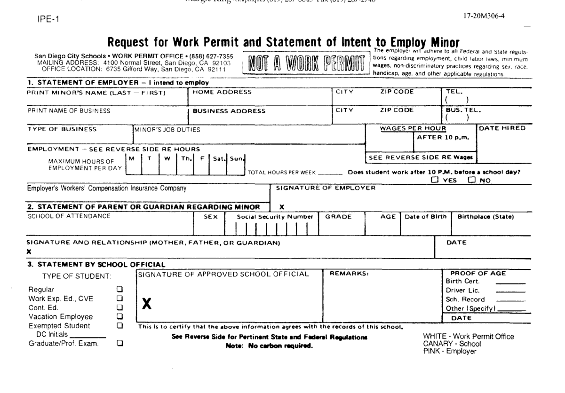
When processing your students under age 18, who are in Cooperative Vocational Education (CVE) (paid) internship, please make sure that your school’s work permit signer receives a copy of the signed CVE Training Agreement. The Employer Outreach Specialist (EOS) at your site is a good contact for getting your work permit applications signed. The work permit issued will reflect that the student’s internship is a CVE one. Ideally, the work permit application and the signed CVE form will be sent to the Work Permit office together at Revere Center Room 3.

Note: Please order these forms from the following:

Work Permits Work Permit Office 858-627-7355

